Nischal Shrestha
Coventry University Student ID Number: 17103446
B.Sc. (Hons.) Computing, Softwarica College of IT and E-commerce, Coventry University
ST4005CEM Database System
Giriraj Rawat

- Create table customer with column name customer_id, customer_name, contact_number and country.
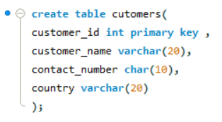

- Create table order with column name order_id, order_date, amount, customer_id (foreign key referencing customer)
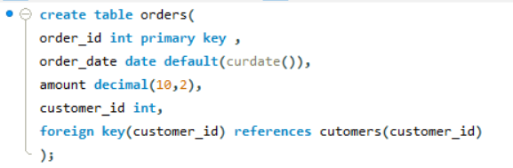

- Insert a sample data minimum 5 records in both table.
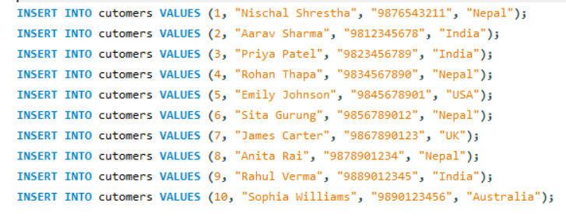
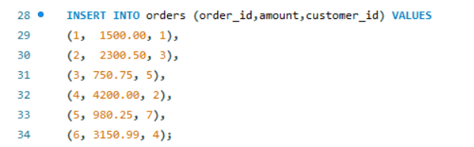

- Update the contact name of customer with ID 3 to 'laxmi prasad'.
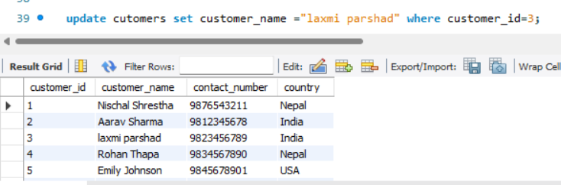

- Update the amount of order with ID 2 to 999.99.
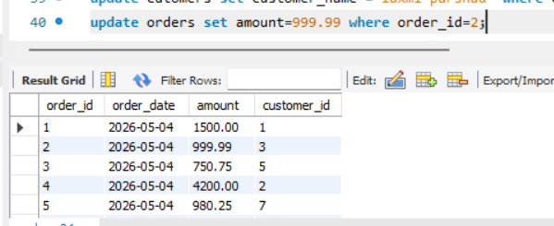

- Delete the customer with customer_id = 5.
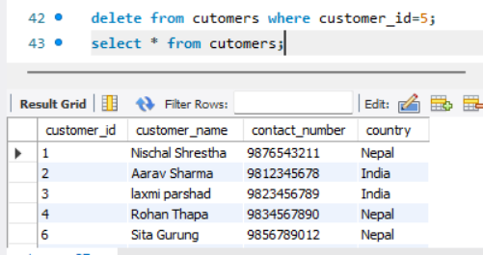

- Delete all orders with an amount less than 1000.
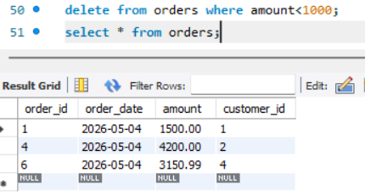
- list all orders sorted by amount in descending order.
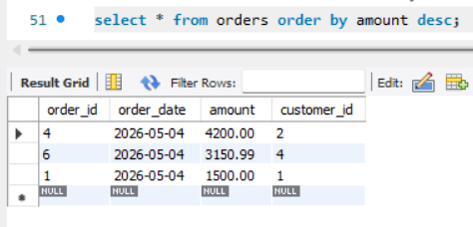

- Display the top 5 most expensive orders.
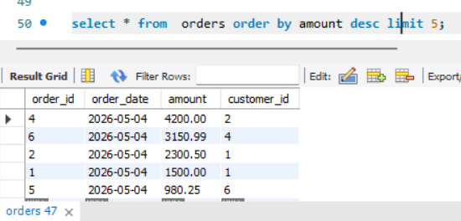

- Show customer names sorted alphabetically.
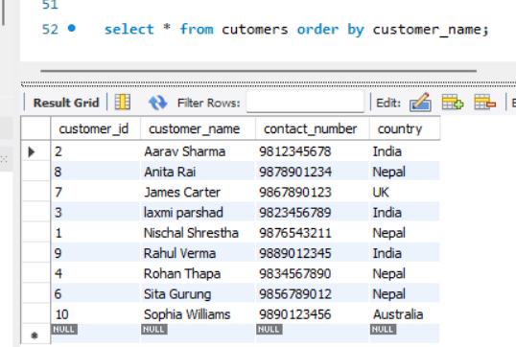

- Get the 3 most recent orders by order_date.

